General Instructions for setting up Newtifry and Pushingbox.

(Most push notification services have a similar setup.)

This is my notification setup for a Moister Sensor, but it can be used to trigger other things, so the setup is pretty generic.

I’ve done a few projects now using Newtifry, the other projects I’ve showed how to setup it as well. For this project I decided to just do generic instructions, and refer people to these if they need help setting up.

Step one: install the newtifry app on your android device.

<https://play.google.com/store/apps/details?id=com.newtifry.android>

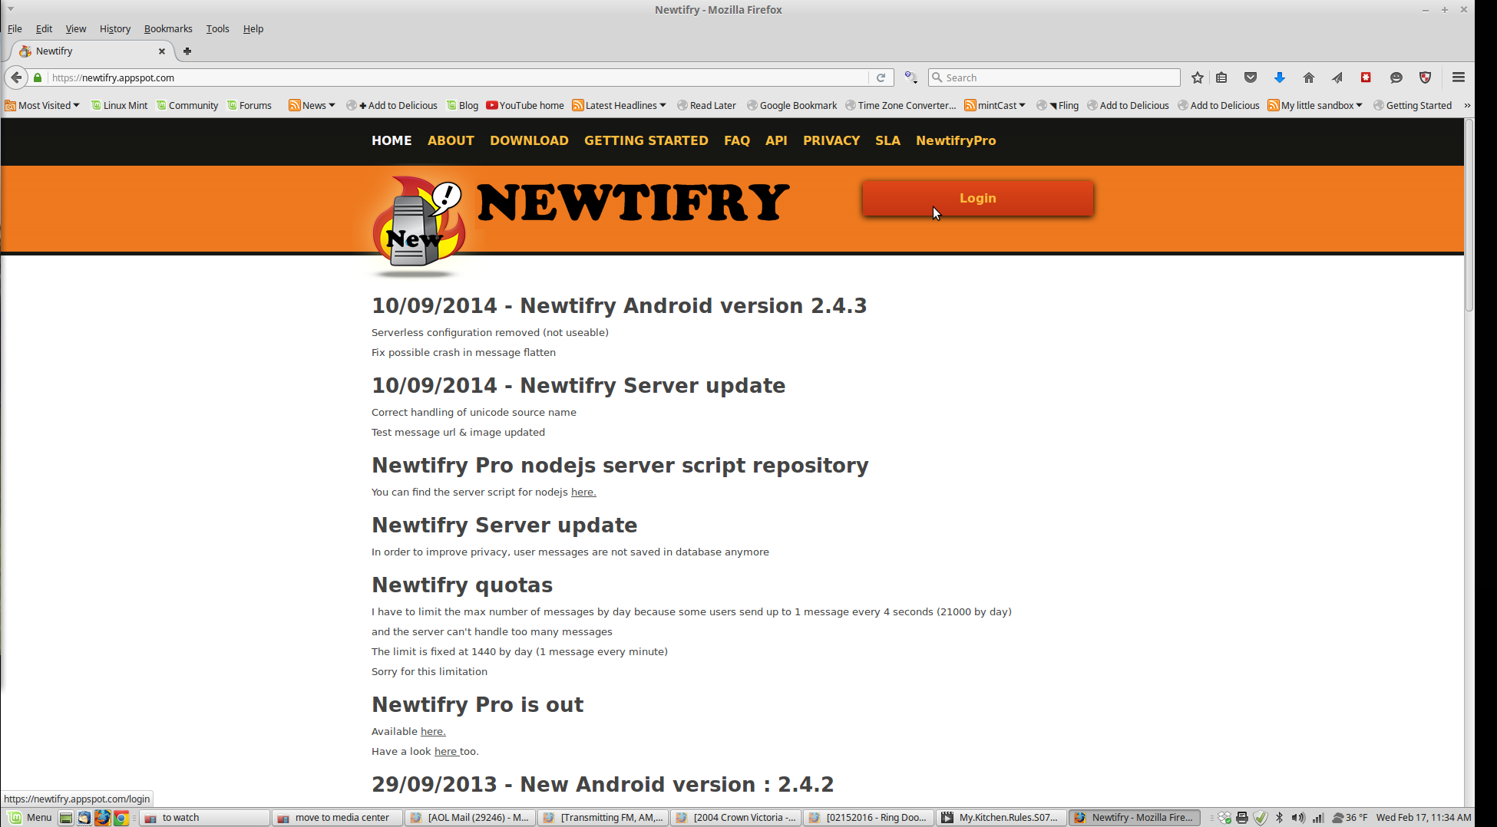

2. Goto the website: <http://newtifry.appspot.com> and login with your google account you used on your phone.

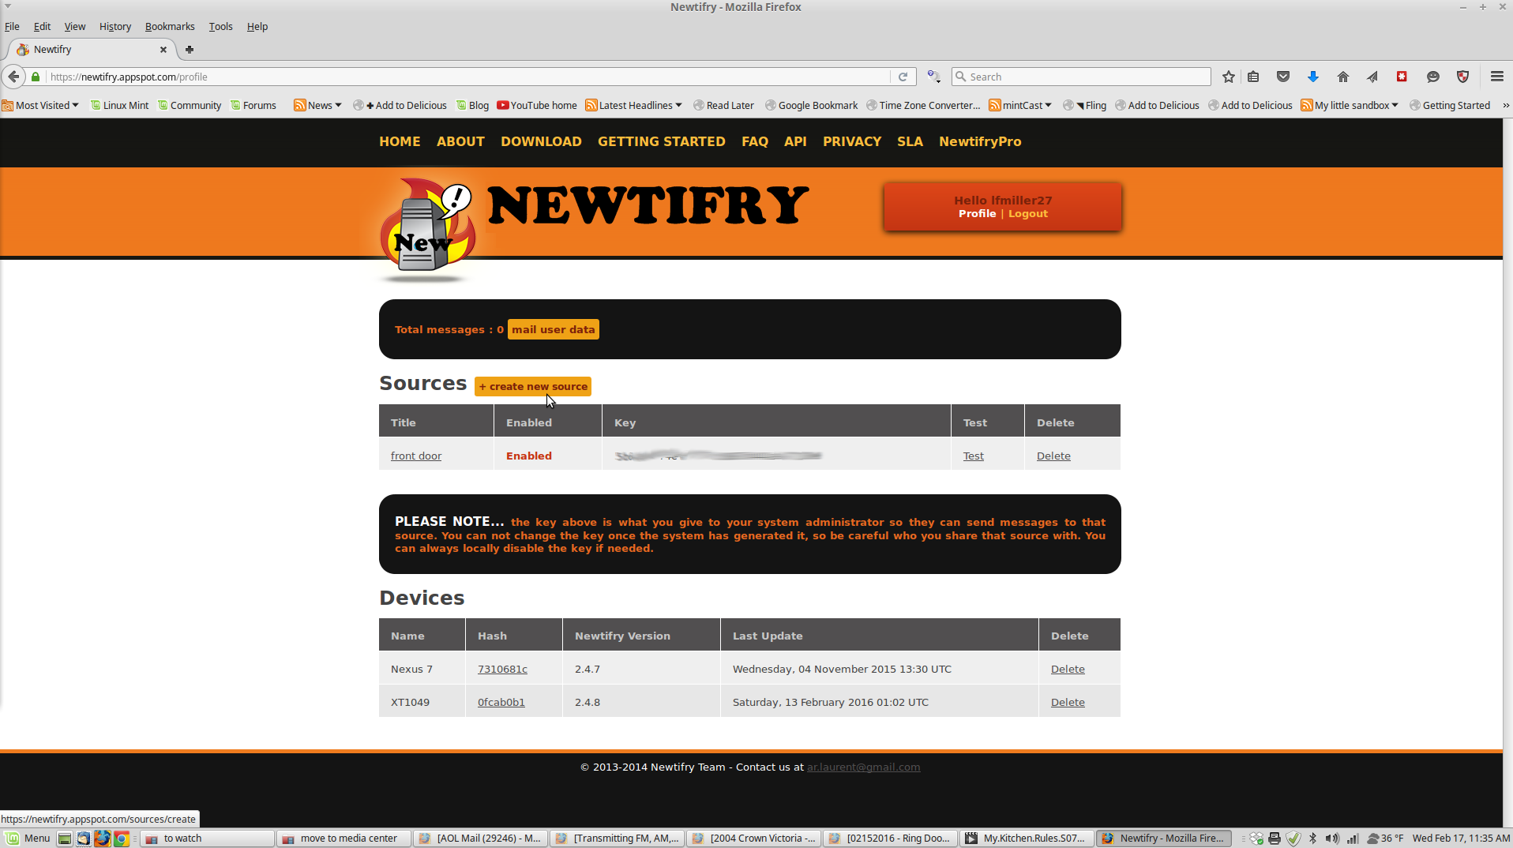

3. Click on “create new source”. And give it a name (for this demo, we are calling it Moister Sensor) also click on “enable”

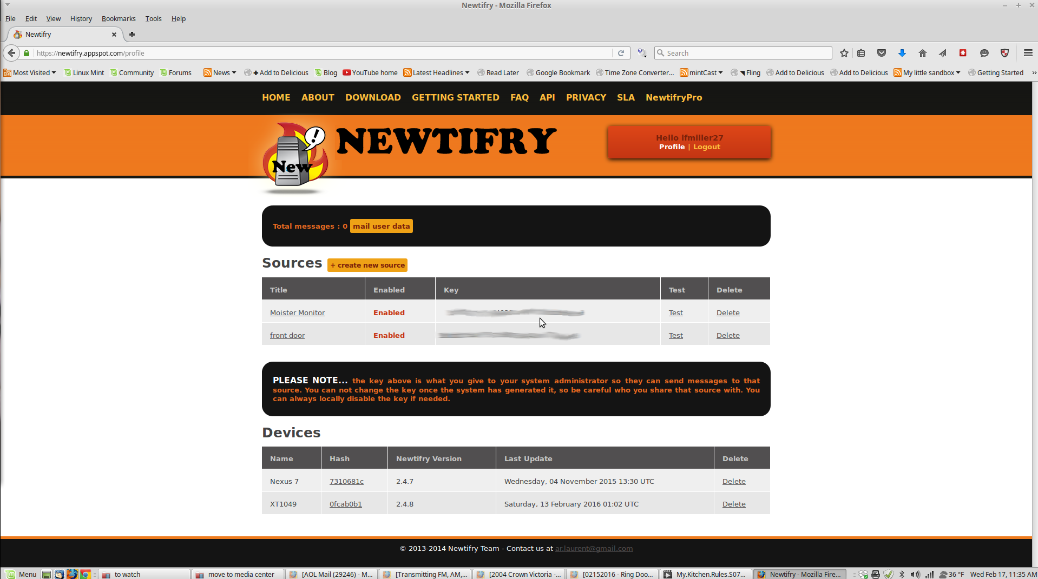

4. You’ll return to the above screen your newly created “Source” will have a “key”. You’ll need this key to setup a trigger on pushingbox.com

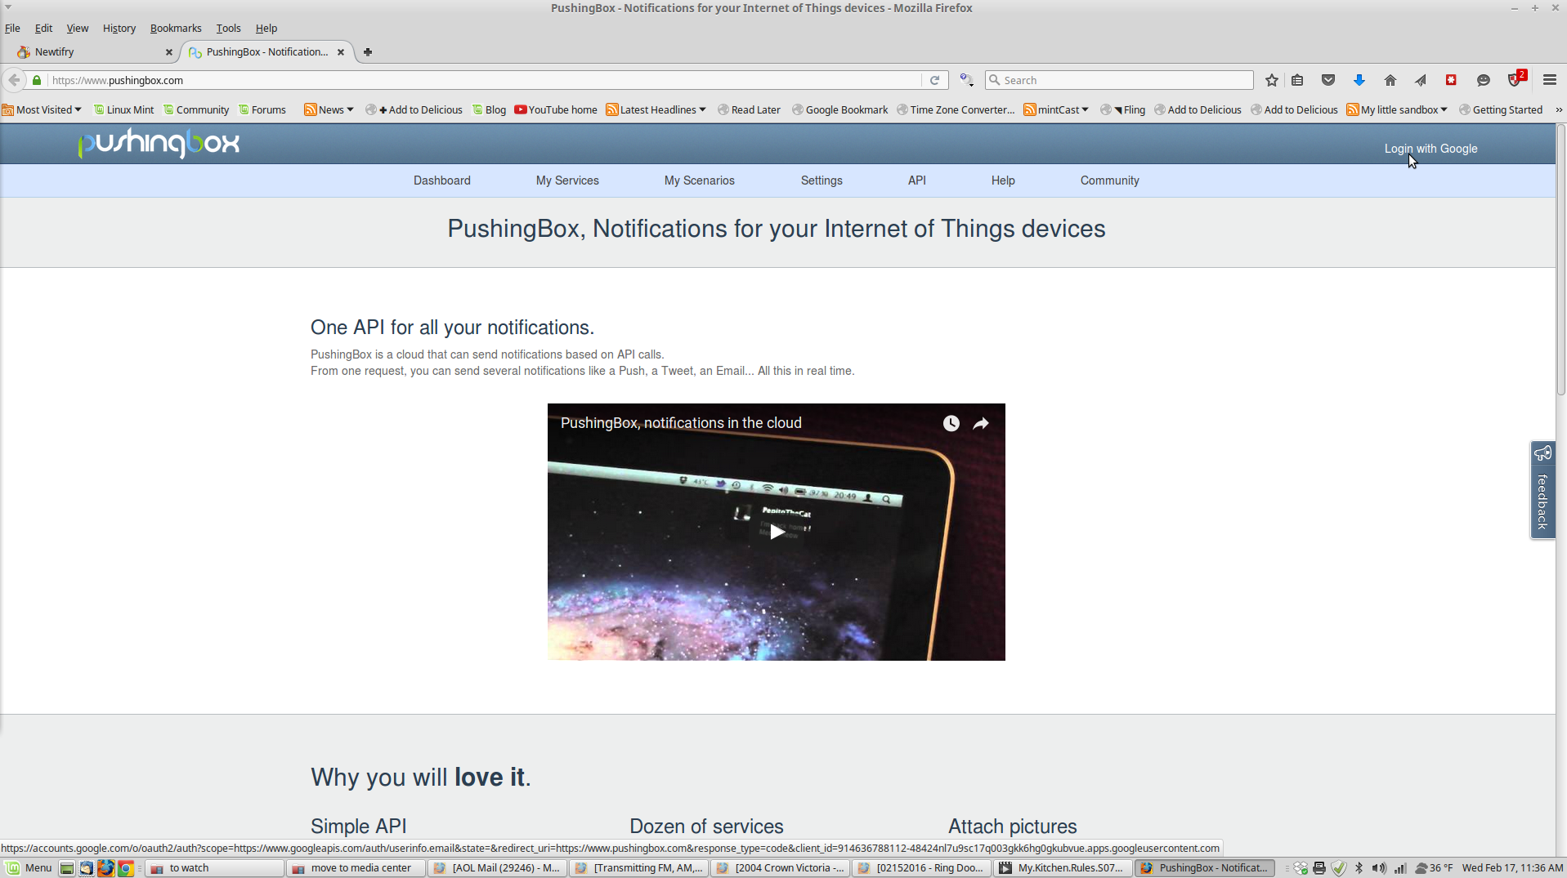

5. Goto pushingbox.com, and login with your google account.

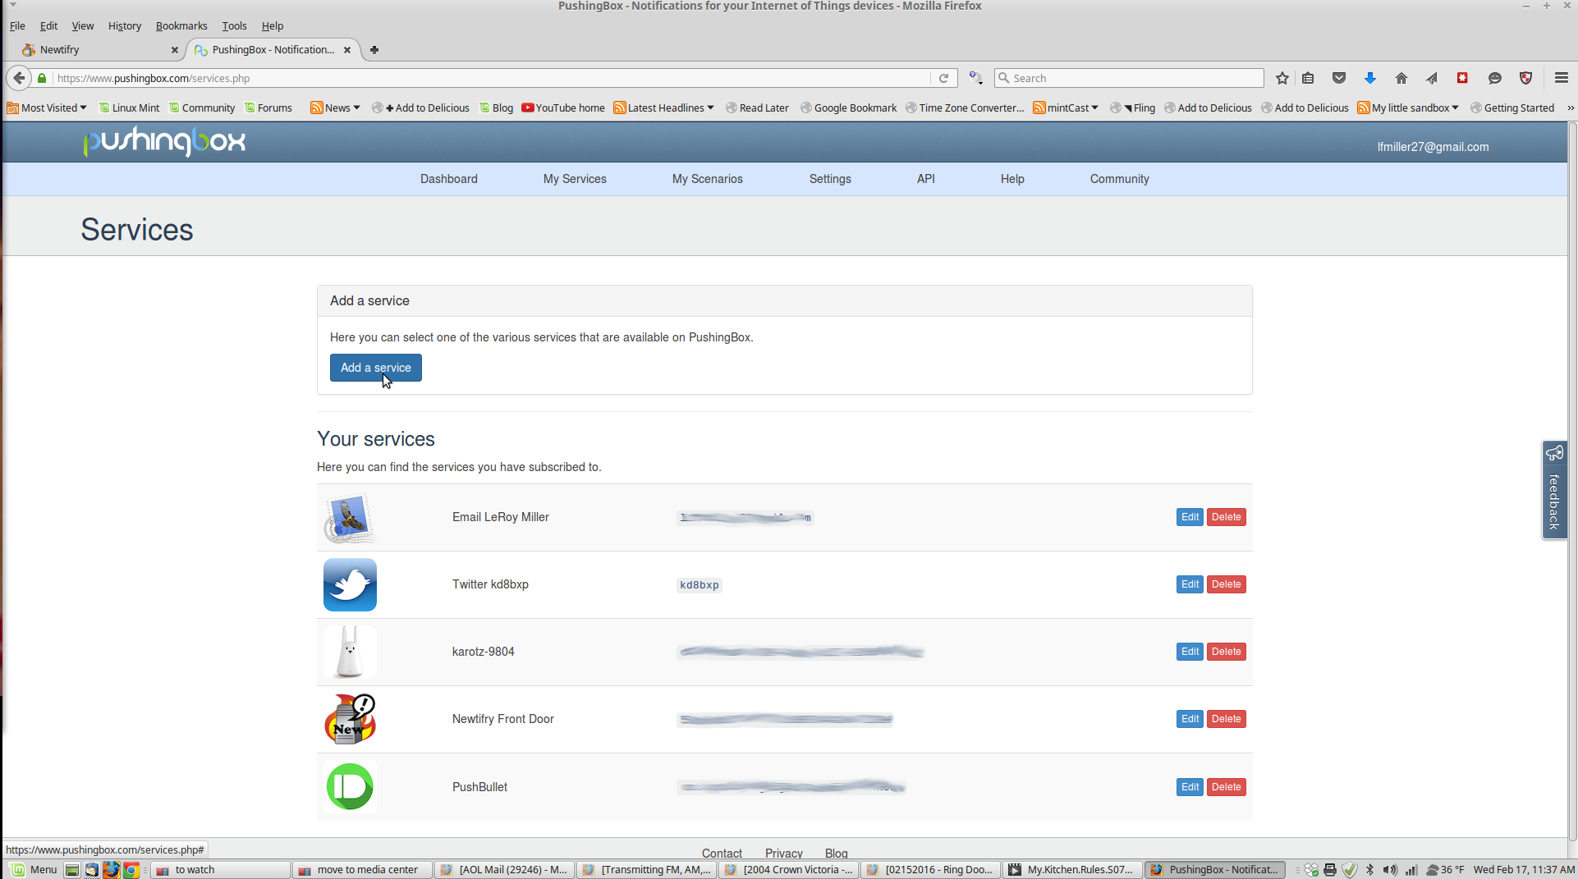

6. You’ll be brought to your “Dashboard”, you’ll want to click on “My Services” and then “Add a service.”

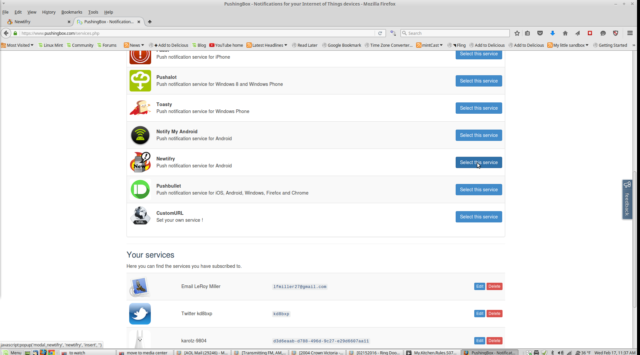

7. You should now see a list of “services” that pushingbox supports. Scroll down to Newtifry and click on “Select this service”. (You see something like what is below)

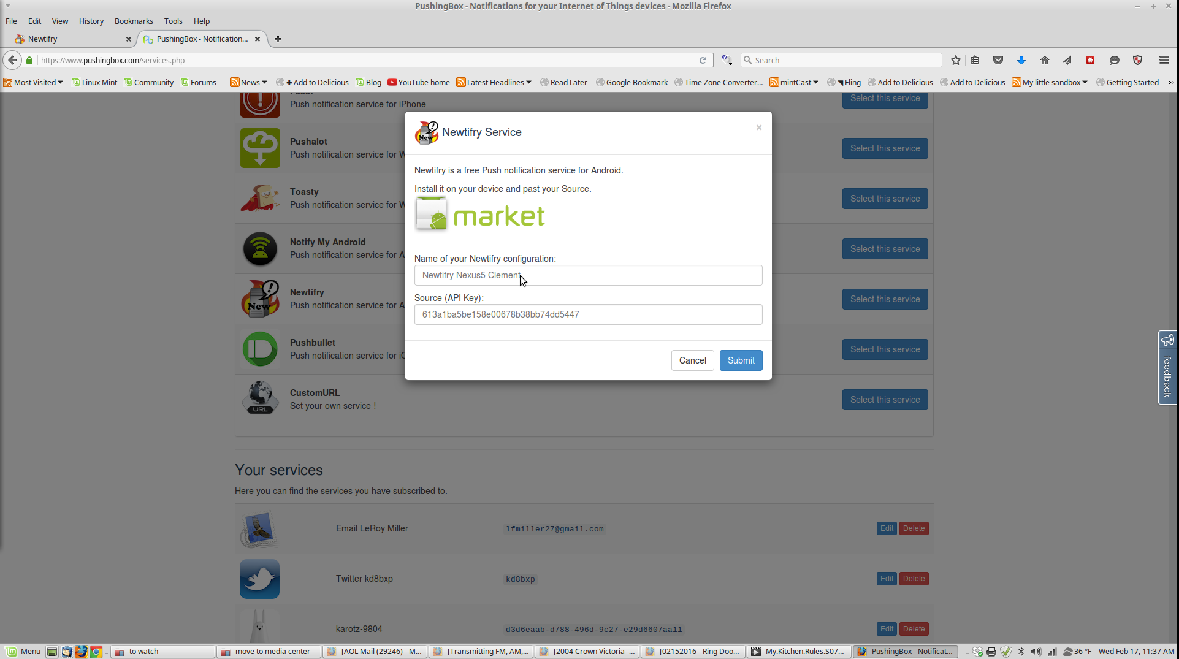

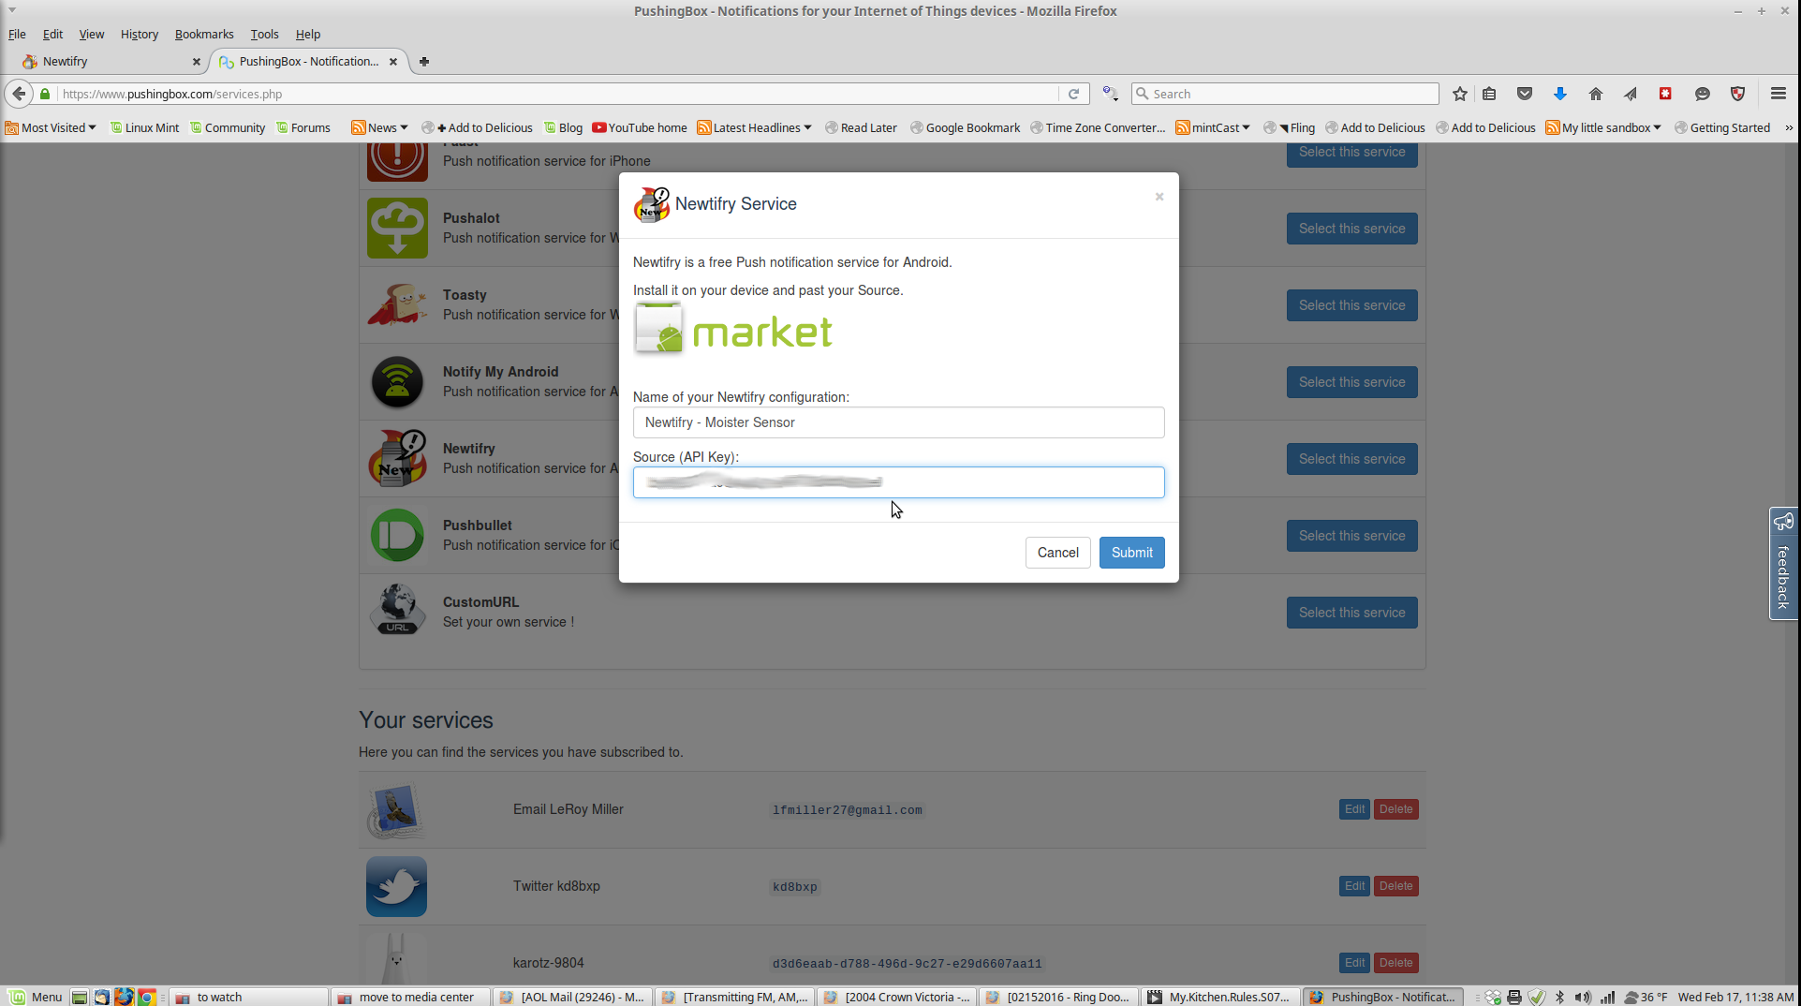

8. Name your new “service” in this case - I called it “Newtifry Moster Sensor”, this is where the Newtifry Key comes in place. (Pushingbox calls it - “Source API Key”) That will bring you back to this screen (below) with your new service.

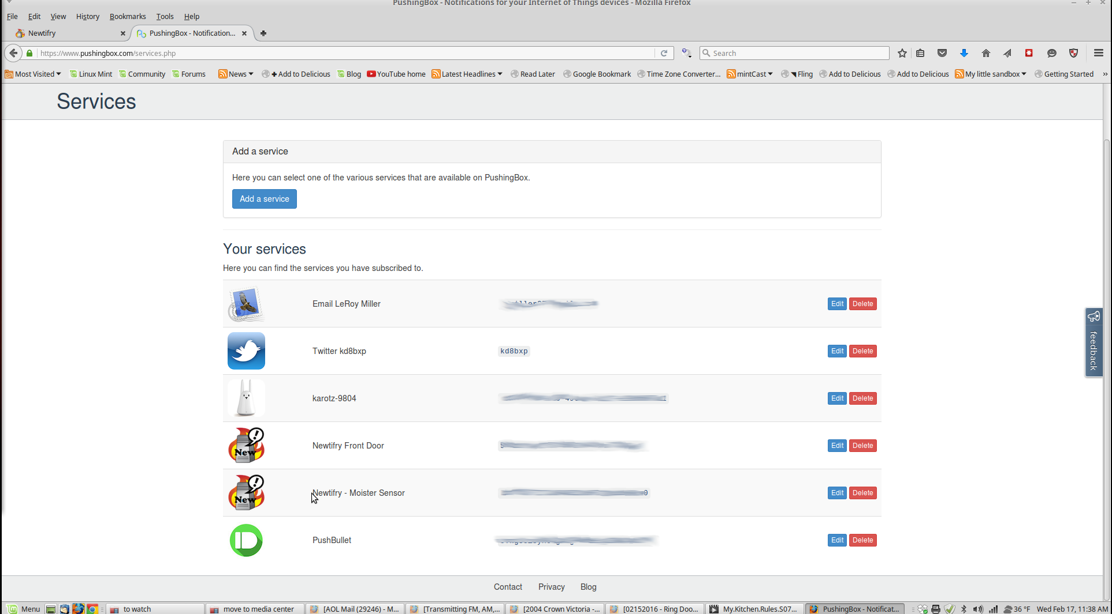

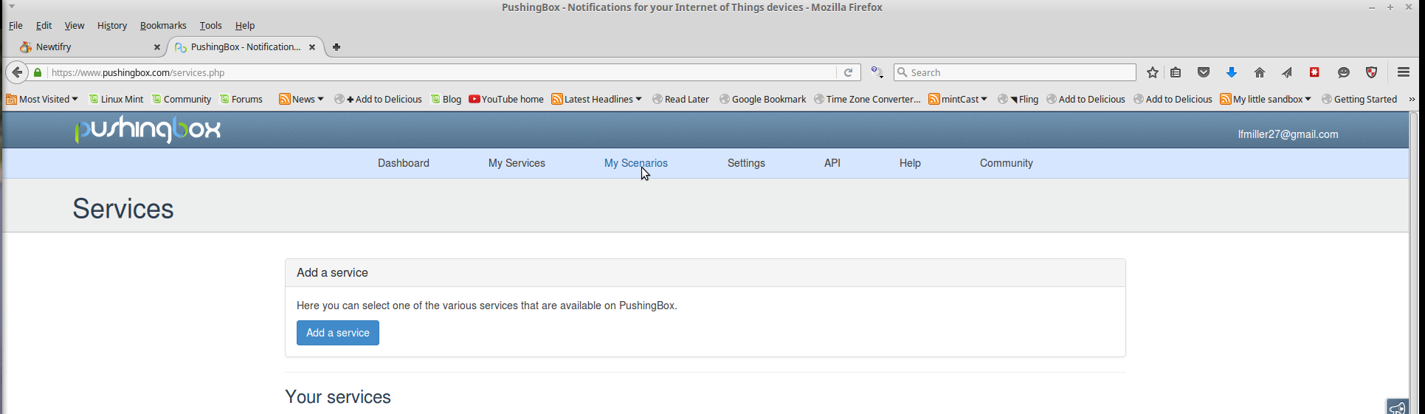

9. Next step - Click on the “My Scenarios” button at the top of the page.

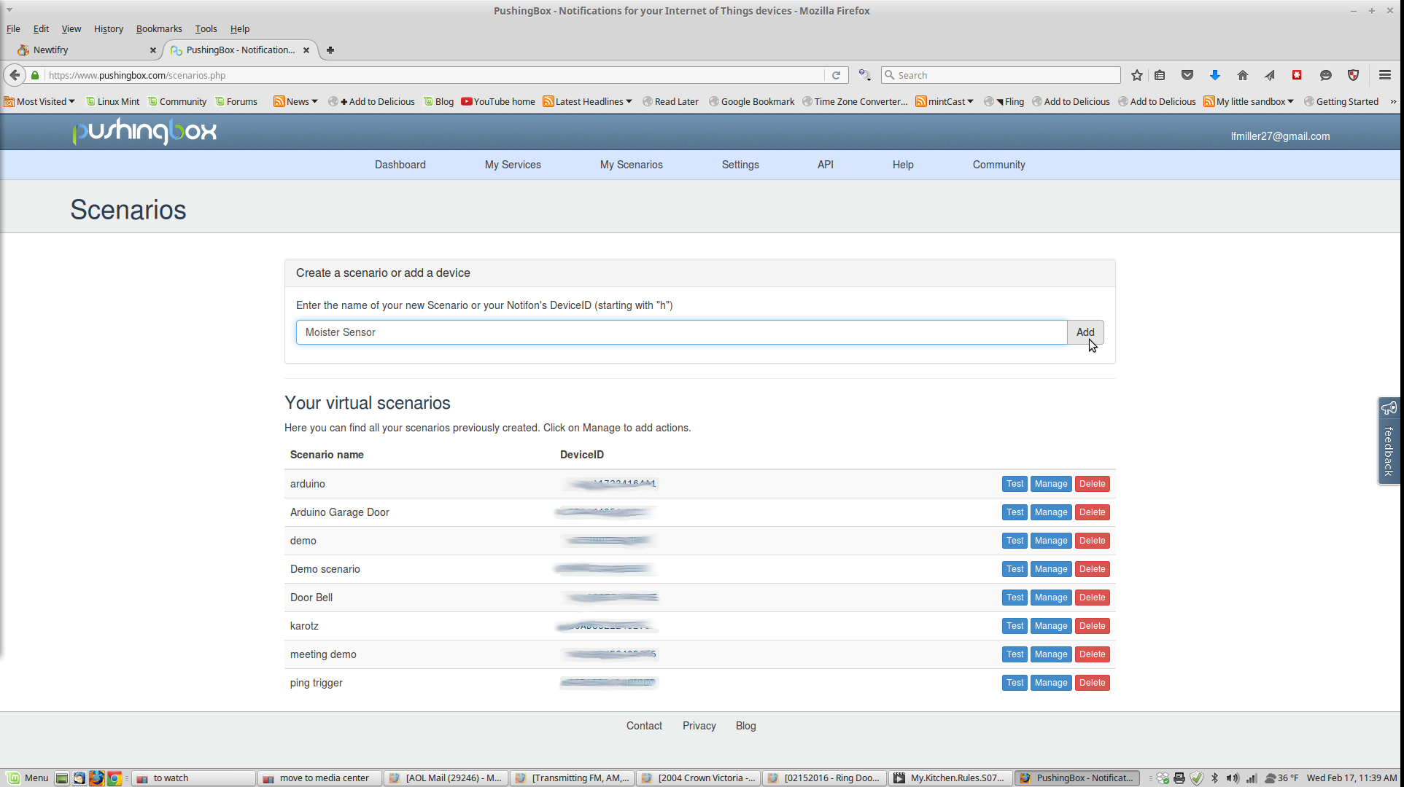

10. That should bring you to the page above, you’ll want to add a Scenario - I called it “Moister Sensor”, click “Add”

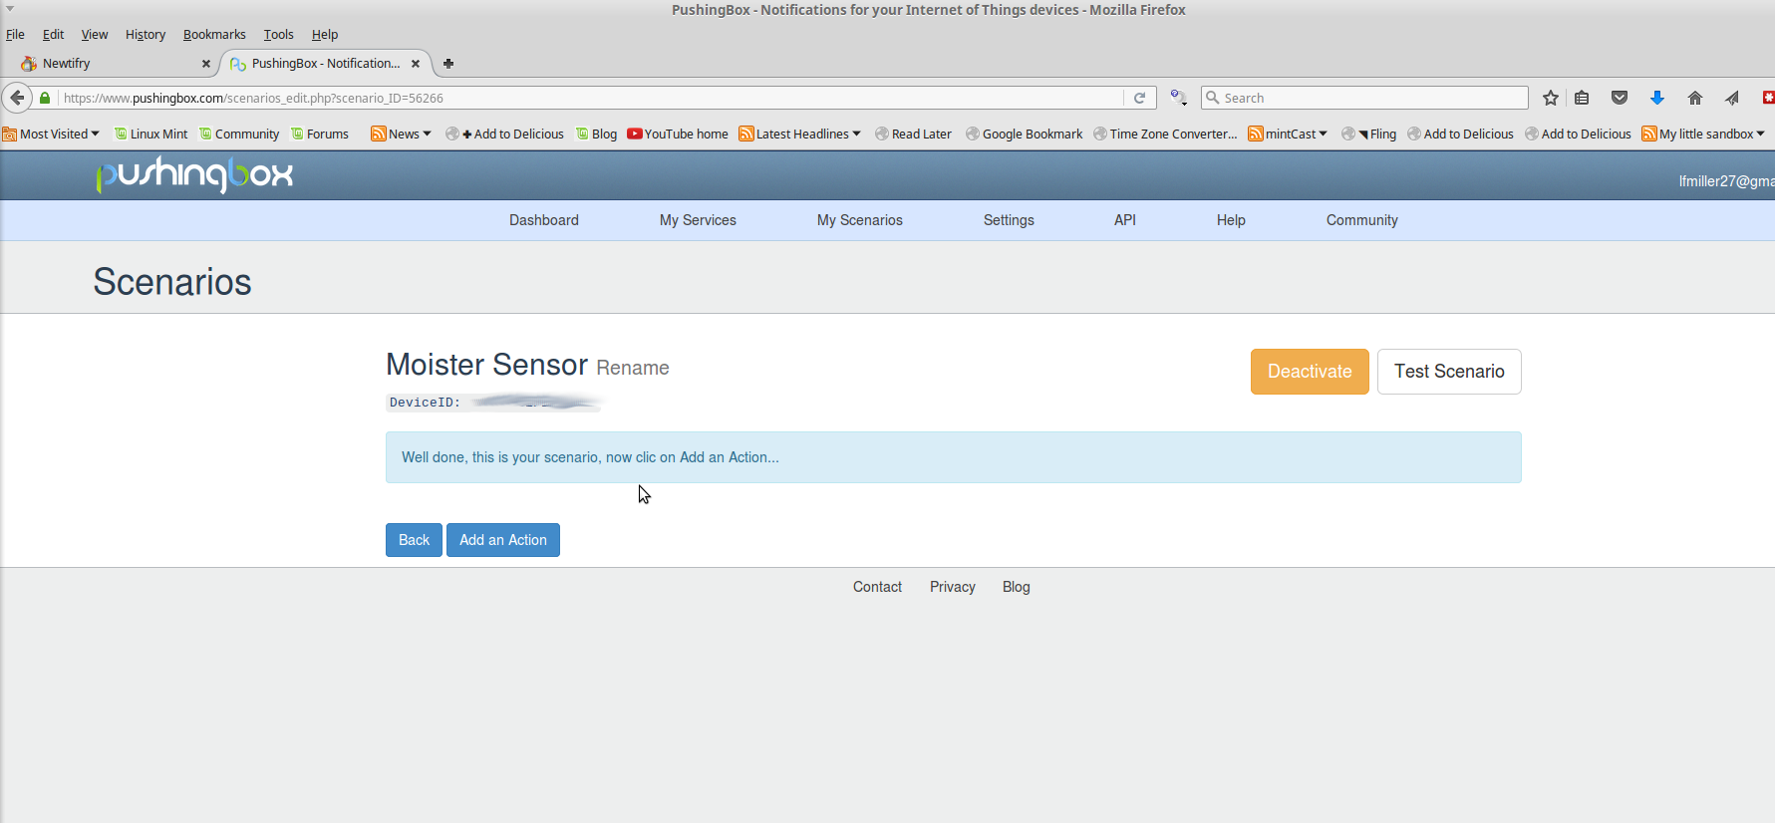

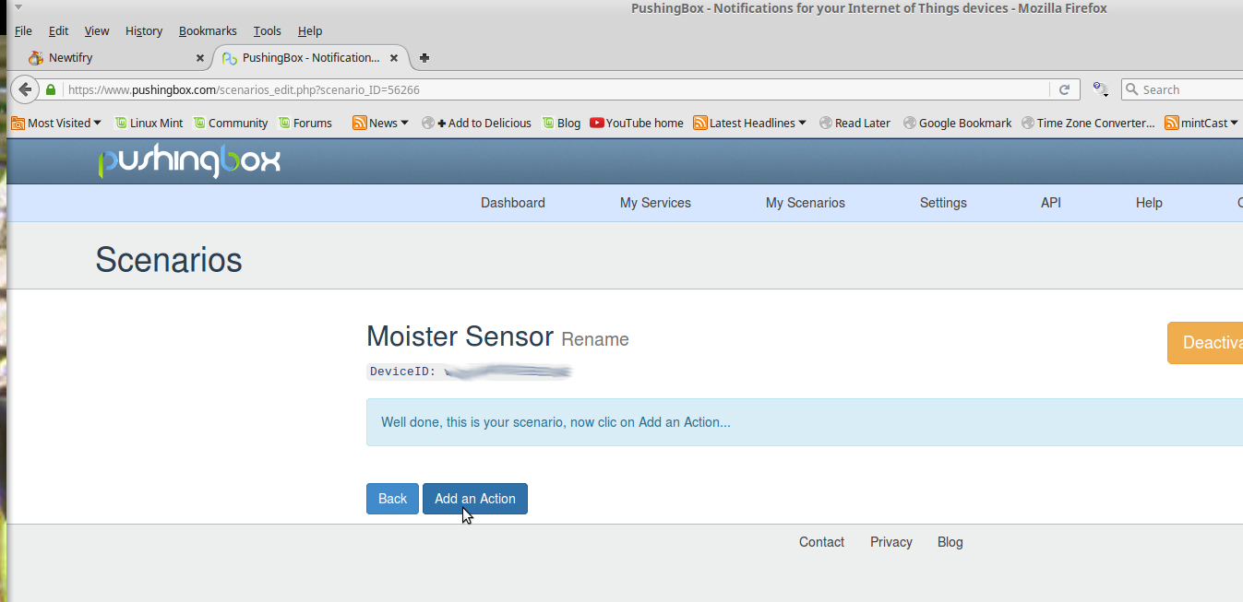

11. Click “Add an Action” That will bring up a list of your “services.” that pushingbox can use

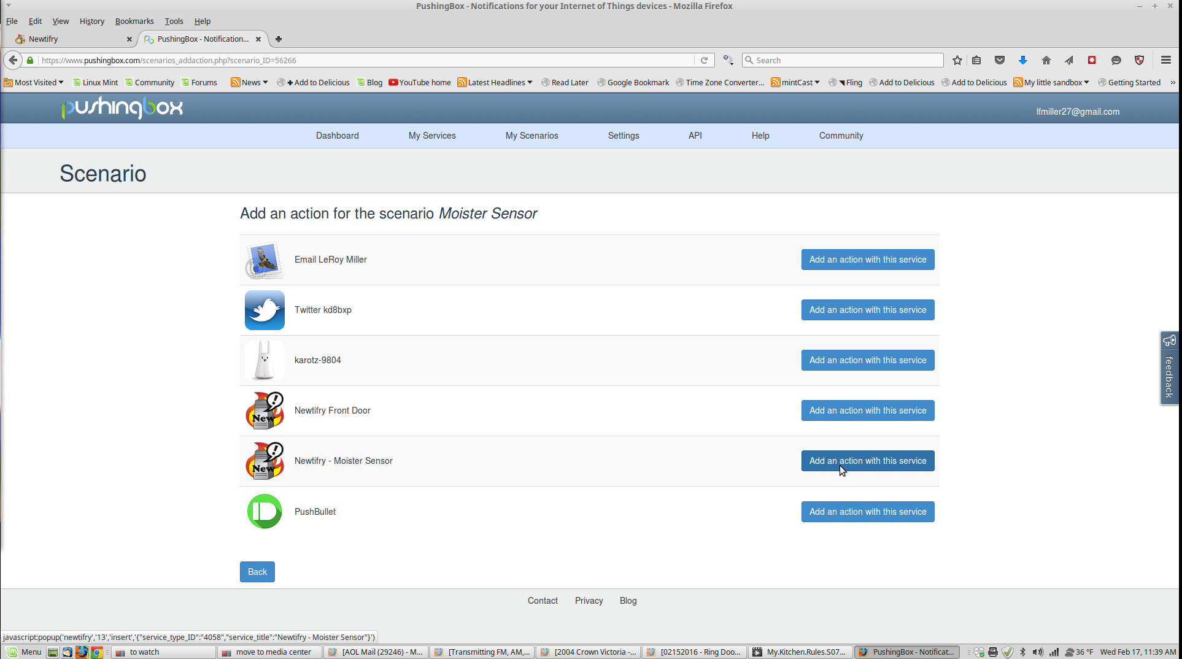

12. Click on the “Newtifry Moister Sensor” service.

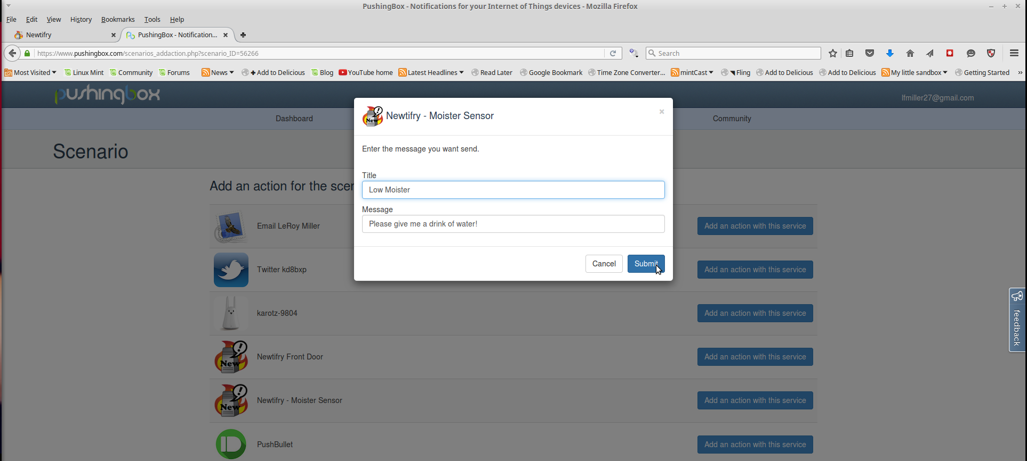

13. Fill in the form - This is where you get to tell newtifry what message to send you. (You can setup a few different scenarios with different messages if you want) For this demo, the title is “Low Moister”, and the Message is “Please give me a drink of water.”

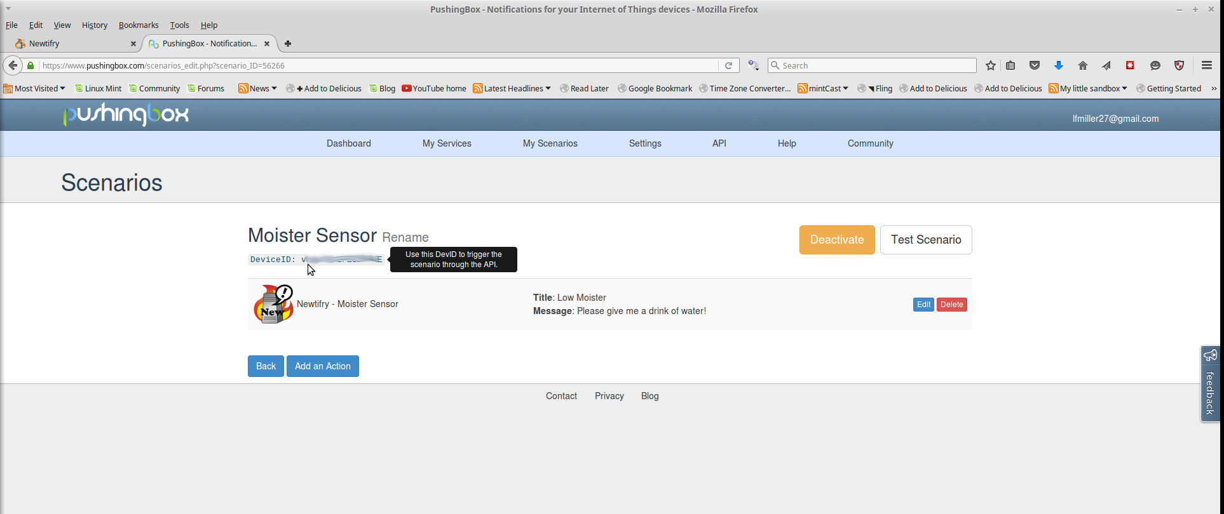

14. As the picture above shows. You now have a scenario and device ID key. You’ll need this key for the final step.

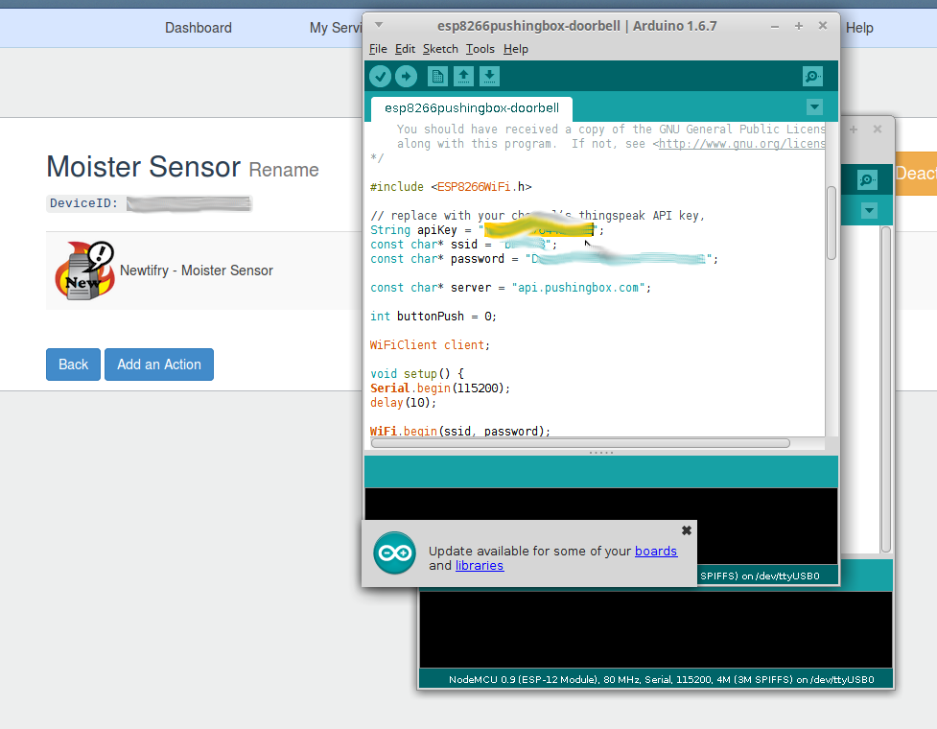

15. Copy the Device ID to the Arduino NodeMCU sketch (the sketch calls it an apiKey). Load the sketch on your nodemcu and give it a try.

That’s it, 15 simple steps to get notifications to your phone from your arduino (or NodeMCU) devices.

Notes:

It should be possible to use one newtifry service and have different messages sent - you just need to add different scenarios, change or modify the arduino sketch for each new scenario.

IE: if you’d like to know that the plant has plenty of water - you could add a scenario that would say some like title “Too Much Water”, and Message - “Hey, Turn off the water I am drowning over here.”

Pushingbox supports variables as well, so you could setup one scenario that could have a different message. (The sketch would need to be modified to do this however, and little beyond the scope of this document.)

You can also add other actions, like for my door bell, I have both pushbullet and newtifry setup to notify if someone pushed the door bell. The actions trigger at the same time.